SQL Database Project: Botanical Garden Plant Collection, Growth and Care Database
Synthetic botanical garden database (SQLite) | Data Science | Individual report
1. Overview
The data is for an imaginary botanical garden, Eldermere Botanical Gardens, over two years (2024 and 2025) and includes the following details: 1,520 plants of 101 species in 64 plots at 8 sites, daily weather data, monthly growth measurements, care given and the pests/diseases affecting each plant. It has 10 related tables, 82 columns and 46,242 rows. Four tables exceed the 1,000-row requirement: growth_measurements (29,514), treatments (8,294), weather_daily (5,848) and plants (1,520). There is coverage of all four scales of measurement (Section 3) The database is a SQLite database file called botanical_garden.db (around 4.3MB).
2. How the data was generated
The data was generated with one python script (botanical_garden_generator.py, Section 6), with only libraries that are standard in Python (random, sqlite3, math, datetime, collections, pathlib). Nothing was downloaded. The garden, staff and all plant life is fictional, as is the general knowledge used: common species with generic characteristics (light, water and winter needs, height etc.), the seasons and climate of southern England and common horticultural practice. Random seed is set (2025), re-run rebuild will produce the same database (checked by comparing file hashes after two runs). Tables are created in dependency order and each foreign key contains a reference to a row that is already created. Instead of creating columns for each individually, the script mimics a garden for every week, meaning that growth, health, care and incidents are all part of the same process.
Families and species (59, 101). There are 59 families and 7 growth forms (41 herbs, 16 shrubs, 13 trees, 12 succulents, 8 ferns, 7 climbers, 4 grasses) and 3 life cycles. All have a native region, light and water requirements (ordinal), minimum temperature, maximum height, and an evergreen flag and a pet-toxicity flag (40 species). The simulation is controlled by a hidden growth rate per species. Staff, plots and sites. Each site has eight plots that have been prepared for the site (peat and shade at Fern Gully, sand and sun in the Arid House), soil pH is dependent on soil type. 24 staff, including gardeners, horticulturists, botanists, technicians, hold a qualification and years of experience depending on their role and there is a member who is responsible for each plot.
Plants (1,520). Plants are planted in the correct position, within a plot and the right kind of plant for the habitat; a few tender species are also cultivated in the Walled Garden to meet frost. Planting dates run from 2024-01-01 to 2025-06-15. Origin (659 nursery, 522 seed, 249 division, 90 cutting) sets the starting height and there is a hidden vigour factor on each plant. Weather (5,848). Each outdoor site has an offset – the alpine garden is cooler, the walled garden is warmer; glasshouses are climate-controlled; one row per site per day, 731 days; rain is from a two-state Markov chain (so that wet spells cluster, with amounts from a gamma distribution); sunshine is from day length and cloud; and humidity from temperature and rain. The temperature is between -8.6 and 38.9 degrees C.
Growth and measurements (29,514). Growth of each plant follows a logistic curve towards the maximum height; this is scaled up with temperature, sunlight, plot exposure and light requirements, soil moisture, nutrition and health (Tsoularis and Wallace, 2002). A survey is conducted every 28 days that includes measurements of height, stem diameter, number of leaves, a chlorophyll (SPAD) reading, and a health score (1-5) ranging from poor to excellent, plus measurement noise, and deciduous plants shed leaves and outdoor herbs die back in the winter. Treatments (8,294) and incidents (810). Scheduled or follow detection: fertiliser (5,091), pruning (616), supplementary watering (2,028), pest control (438) and fungicide (121). There are nine (9) incident types with a weather or condition rule (aphids, spider mite, mealybug, powdery mildew, leaf spot, slugs, root rot, frost damage, and scorch) and a total of 198 incidents have no treatment, 34 are unresolved. Total plants after end of experiment = 1,348 plants alive + 65 dead plants + 107 removed plants. Validation. Data integrity is OK, there are no foreign-key violations and no measurements outside of a plant's life.
3. Database schema
The schema has 10 tables and 13 foreign keys (Figure 1): species link to families; plots to sites and staff; plants to species and plots; and growth_measurements, treatments and incidents to plants and staff, with an optional link from an incident to its treatment. weather_daily has the composite key (site_id, obs_date). The four scales of measurement covered are listed in Table 1. Dates are ISO-8601 text.
Table 1: Measurement scales covered
Scale | Columns
Nominal | family_name, order_name, is_flowering, scientific_name, common_name, growth_form, lifecycle, native_region, evergreen, toxic_to_pets, site_name, site_type, climate_controlled, first_name, last_name, role, plot_code, soil_type, irrigation, tag_code, origin, status, in_flower, product, treatment_type, issue_type
Ordinal | light_need (Low < Medium < High), water_need (Low < Moderate < High), sun_exposure (Shade < Partial < Full), qualification (Certificate < Diploma < Degree < Doctorate), severity (Mild < Moderate < Severe), health_score (1 to 5)
Interval | min_temp_c, soil_ph, elevation_m, established_year, birth_year, planted_date, end_date, measure_date, treatment_date, detected_date, resolved_date, obs_date, temp_min_c, temp_max_c
Ratio | max_height_cm, area_ha, years_experience, area_m2, initial_height_cm, rainfall_mm, sunshine_hours, humidity_pct, height_cm, stem_diameter_mm, leaf_count, chlorophyll_spad, quantity_ml, cost_gbp

Figure 1: Entity relationship diagram: 10 tables, 82 columns, composite keys marked.
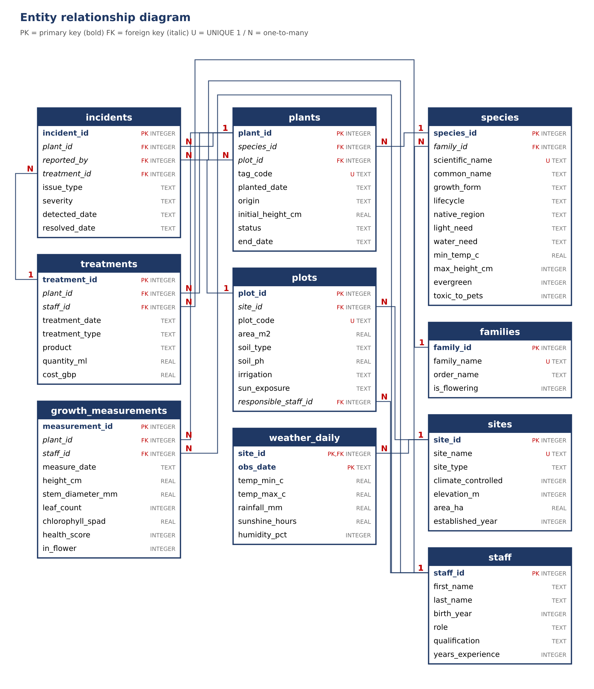
4. Justification for separate tables and constraints
Table 2: Tables, rows and reasons
Table | Rows | Reason for a separate table
families | 59 | Family and order stored once; a family has many species.
species | 101 | Light need, water need and maximum height stored once per species, not per plant.
sites | 8 | Site type, elevation and climate control belong to the area, not to each plot.
staff | 24 | Staff details stored once; referenced by plots, measurements, treatments, incidents.
plots | 64 | Soil, irrigation and sun exposure belong to a plot shared by many plants.
plants | 1,520 | Facts that do not change (species, plot, planting date, origin) plus the outcome (status, end date).
weather_daily | 5,848 | One row per site per day, shared by all plants of the site. Composite key (site_id, obs_date).
growth_measurements | 29,514 | One row per plant per survey; the number grows with time. UNIQUE (plant_id, measure_date).
treatments | 8,294 | A plant has many treatments with their own product, quantity and cost.
incidents | 810 | A plant has many incidents; treatment_id is NULL if none was given.

Constraints. SQLite enforces foreign keys only when PRAGMA foreign_keys = ON is set on the connection (SQLite, n.d.a); the generator sets it. Every table has a primary key, required fields are NOT NULL, and names, codes and tag codes are UNIQUE. Value lists (growth form, life cycle, light and water need, site type, role, soil, irrigation, sun exposure, origin, status, treatment and issue type, severity) and ranges (humidity 0 to 100, soil pH 3 to 10, health score 1 to 5, positive heights and costs) are CHECK constraints. Cross-column CHECKs say a plant is Alive with no end date or Dead/Removed with one on or after planting, a day's maximum temperature is not below its minimum, and an incident is not resolved before it is detected. NULLs are used only where a value is absent for a reason: plants.end_date (1,348, still alive), treatments.product and quantity_ml (616, pruning), incidents.resolved_date (34) and incidents.treatment_id (198). Indexes cover plants(plot_id), growth_measurements(plant_id, measure_date), treatments(plant_id) and incidents(plant_id). The design follows the relational model (Codd, 1970), third normal form.
5. Ethical and data privacy discussion
Synthetic data. Consent and re-identification not an issue, no real person or collection is represented, staff names are assembled from lists and match is coincidence. The species are actual, but the characteristics listed are approximations and do not constitute a basis for real planting or determining the safety of plants around pets.
A real garden database would contain personal information about staff (names, birth year, qualifications) which would require a lawful basis, limited collection and retention and the birth year would be the only data stored in the schema. Entering all measurements, treatments and incidents into a named person could be of workers and analysis would be by plot or site using pseudonymised identifiers. A real system would limit the location of rare plants to the plot level, as illegal collectors could use these to target the plants and trade in many wild plants is regulated by CITES (CITES n.d.).
Re-identification and fairness. If the number of staff is 24 or fewer, individuals might be identified by role and qualification and birth year, therefore the results would be aggregated. There's a lot of variation in plant health from soil, to irrigation, to exposure, and if we were to assess a gardener by their plants' performance, we would be much harder on the ones who aren't as well measured, like the glasshouses. Limits of realism. Assumptions for distributions: weather is generated, plants grow according to one logistic equation, with simple factors, there are no pollinators, weeds, or soil biology. The database is an illustration of technique and not of any actual garden.
6. Code
GitHub repository: https://github.com/talhaumairm8/SQL-db
This report introduces only comments where a design decision requires explanation, the rest of the generator is in botanical_garden_generator.py (691 lines, provided with this report). When you run python botanical_garden_generator.py, you'll get a list of row counts and validation checks, plus an exact copy of botanical_garden.db. Growth_measurements joined to plants, plots and species shows that plants in plots with a light value that is similar to that required by the species have a higher average health score (4.12) than those in plots where the light is mismatched (3.37).
7. Evidence: first rows of each generated table
Figures 2 to 11 show the first four rows of each table, with the number of rows in the header, rendered from botanical_garden.db.
Figure 2: plants (1,520 rows)  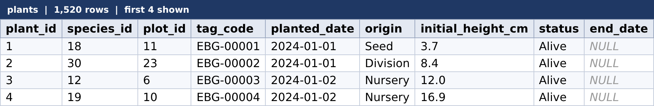 | Figure 3: growth_measurements (29,514 rows)  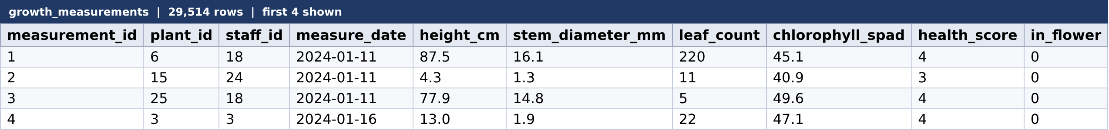
Figure 4: weather_daily (5,848 rows)  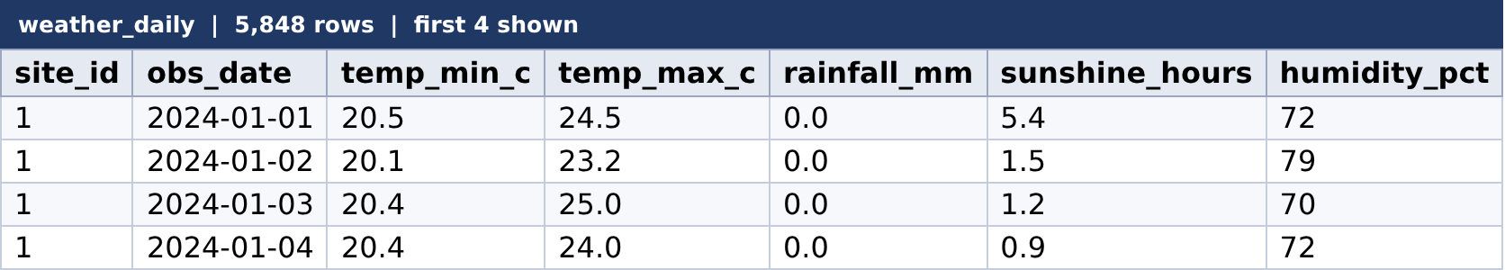 | Figure 5: treatments (8,294 rows)  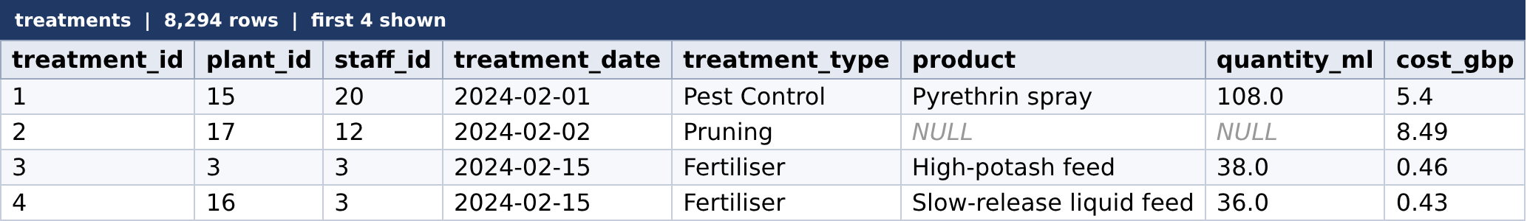
Figure 6: incidents (810 rows)  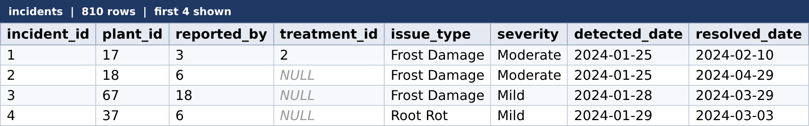 | Figure 7: species (101 rows)
Figure 8: plots (64 rows)  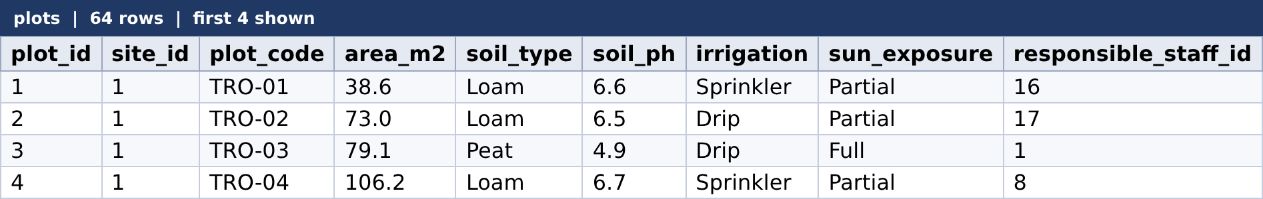 | Figure 9: staff (24 rows)  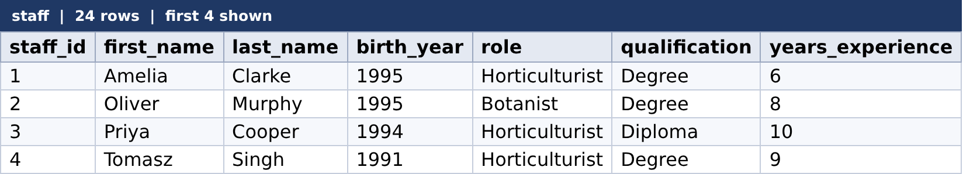
Figure 10: sites (8 rows)  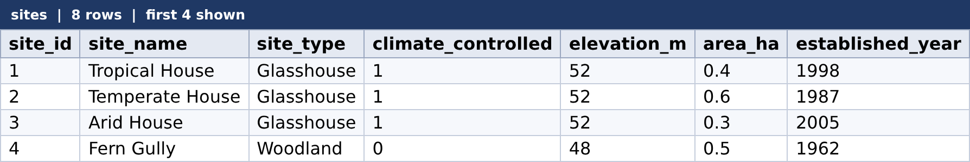 | Figure 11: families (59 rows)  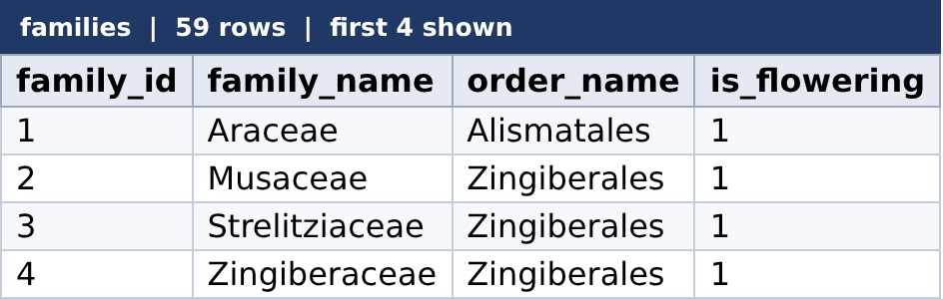
References
Codd, E.F. (1970) 'A relational model of data for large shared data banks', Communications of the ACM, 13(6), pp. 377-387.
legislation.gov.uk (2018) Data Protection Act 2018. Available at: https://www.legislation.gov.uk/ukpga/2018/12/contents (Accessed: 5 November 2026).
SQLite (n.d.a) SQLite foreign key support. Available at: https://www.sqlite.org/foreignkeys.html (Accessed: 5 November 2026).
Stevens, S.S. (1946) 'On the theory of scales of measurement', Science, 103(2684), pp. 677-680.
The Convention on International Trade in Endangered Species of Wild Fauna and Flora (CITES) (n.d.) CITES. Available at: https://cites.org/ (Accessed: 5 November 2026).
Tsoularis, A. and Wallace, J. (2002) 'Analysis of logistic growth models', Mathematical Biosciences, 179(1), pp. 21-55.

